End-to-End Machine Learning

Non-Fungible Tokens (NFTs) Floor Price Prediction

Farzana Rahman Mr. Intisar Tahmid Naheen   
*Department of Electrical & Computer Engineering Department of Electrical & Computer Engineering*   
*North South University, North South University, Bashundhara Bashundhara  
Dhaka – 1229, Bangladesh Dhaka – 1229, Bangladesh*  
[farzana.rima@northsouth.edu](mailto:farzana.rima@northsouth.edu) [intisar.naheen@northsouth.edu](mailto:intisar.naheen@northsouth.edu)

*Abstract*— Digital assets called Non-Fungible Tokens (NFTs) are used to represent things like artwork, collectibles, and in-game items and are also sold as NFTs in wide range. They are typically stored and minted in smart contracts on a blockchain and exchanged online frequently with cryptocurrencies. A digital asset's uniqueness is confirmed by the NFT. Their assessment is done in several ways, and currently, the most popular method is by using some major metrics to measure their values and demands in the future. Floor price is the most important one in all of them. The floor price represents the smallest amount of money anyone can spend to become an owner of an NFT in a specific project (a member of a project). Floor pricing are established by the people who hold NFTs inside a project. The higher the floor price, the more valuable and reliable the collection is as a whole for involving the community in a project. So, in this project the dataset is created by the price factors as numerical data and several models are used as Linear Regression, KNN, SVM, Random Forest, Confusion Metrix, in training and testing the Regression Model. Random Forest Model has given the best accuracy of 96% among all of them. A Machine Learning Web Application ‘NFT Floor Price Authenticator’ is also created to generate the best accuracy to predict the future floor price.

Keywords—Digital Asset, Non-Fungible Tokens (NFTs), Mint, Cryptocurrency, Blockchain, Floor Price, Regression, Machine Learning Web Application.

# **1. INTRODUCTION**

Since early 2021, non-fungible tokens (NFTs) have been receiving tremendous attention in the digital asset market as their prices have boosted substantially. The current most expensive NFT, Pak’s “The Merge”, was sold on December 2, 2021, with almost 30,000 collectors pitching together for a total cost of record-breaking USD 91.8 million. It has been observed that the price of NFTs is significantly influenced by pricing floor [1]: The higher the floor price, the more valuable and reliable the collection is as a whole for involving the community in NFT project. Hence, many investors are making their purchase decisions based on the floor price rank of the NFTs[2]. The floor price for any sort of NFT trading was roughly ten times higher at its peak in September, 2021 than it was in early June 2021. This suggests that NFT trading grew in popularity at that period [3].

## Explaination of this Model Statement

In this task, similar to those machine learning web applications [4], some effective models are applied on this prediction authenticator web application to find floor price static which can show the lowest price at which a specific NFT sells. It is one of the most sought new features within the cryptocurrency industry.

## How Machine Learning Models Predictict Floor Price

Among, Linear Regression, KNN, SVM, Random Forest, Confusion Metrix, in training and testing this Regression Model of this project, Random Forest Model can predict the best accurate result of floor price.

## Contribution

The Website created to predict floor price has the novelty of predicting inaccurate inputs as well as predict the lowest possible price of NFT based on some major metrics as Owners, Sales, Volume (USD), Assets, Market Capitalization, Ratio between owners and assets etc.

# **Related Works**

The authors proposed a global NFT price index using the scarcity of NFTs [5]. The authors built a machine learning model to predict the price of Bored Ape Yacht Club NFTs [6].

# **Methodology**

1. Dataset Description: Here with the correlation matrix the feature is explained:

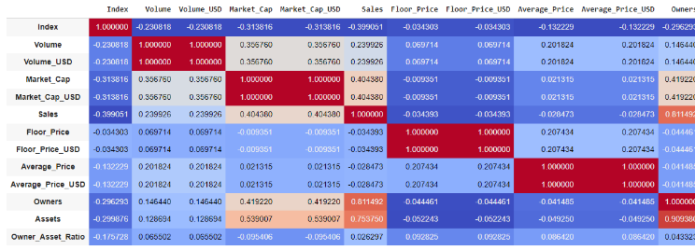

1. Flow Chart

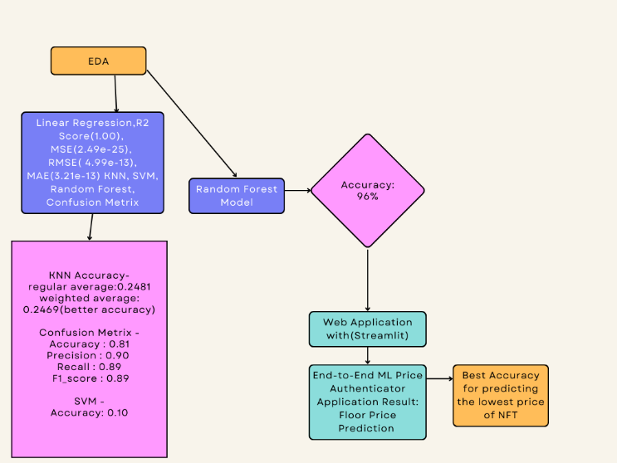

1. Technology Stack: Web Application: Framework for Machine Learning Application: Streamlit.

EDA and Evaluation of Model and their parameters: Google Colab.

1. Picture of Website:

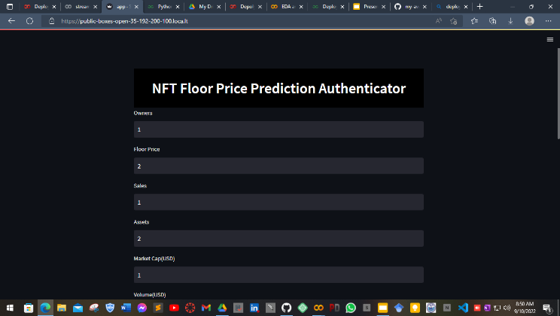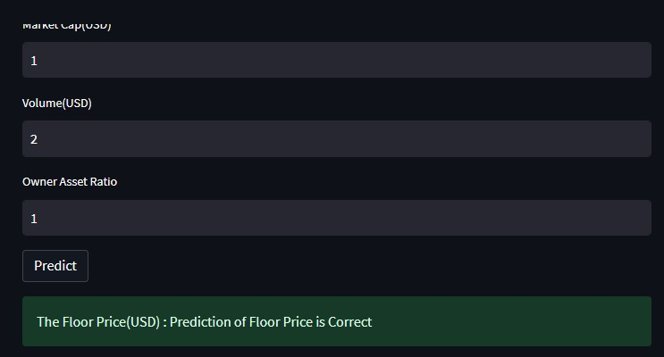

1. Exploratory Data Analysis (EDA):
2. Histograms

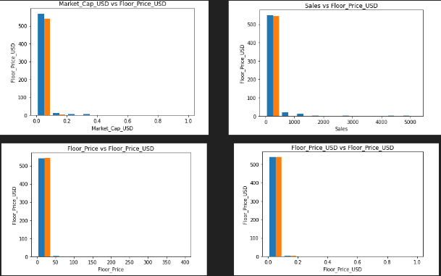

1. Numerical Pairplots:

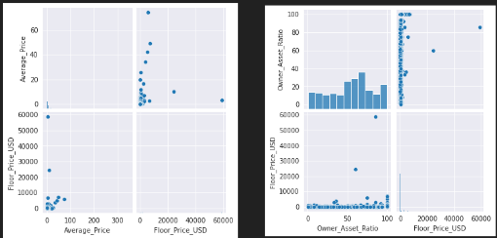

1. Normalization:

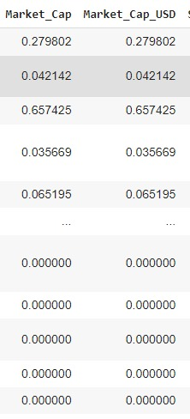

1. Correlation Metrix: 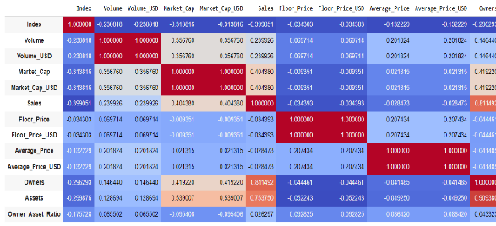
2. Dropping any feature if they seem extremely uncorrelated:

Here from the correlation matrix, we can see “Market_Cap” & “Market_Cap_USD” have values almost closer to zero. Therefore, these datas are not related to “Floor_Price_USD”. That’s why dropping these two columns.

1. Most of the plots are not needed including One hot encoding, Stratified Sampling, Bar Chart, Plot since it is a regression model (because it predicts the price (Floor_Price_USD) of Non-Fungible Tokens (NFT) among all features, therefore no need to balance any data. We need all the datas intact to get a proper result.
2. Best Model explained Mathematically (Random Forest Model) :

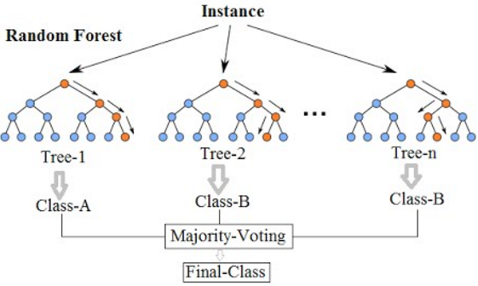

# **Result**

1. Linear Regression: 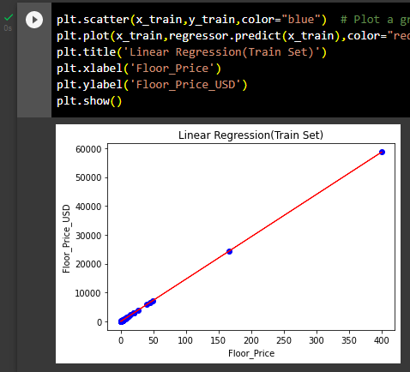
2. R^2 score, RMSE, MSE, MAE:

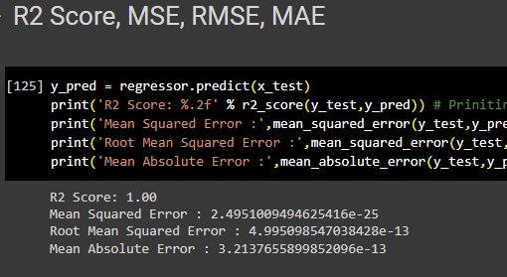

1. KNN:

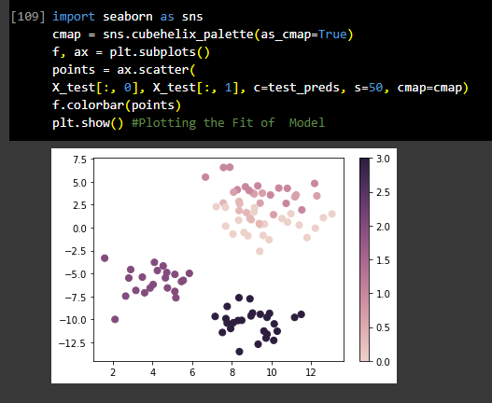

Also improving KNN Performances in scikit-learn Using GridSearchCV:

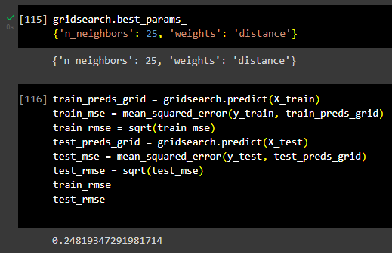

Applying a weighted average rather than a regular average has reduced the prediction error from 0.24819347291981714 to  0.24696965748279318. Although this isn’t a huge improvement, it’s still better, which makes it worth it.

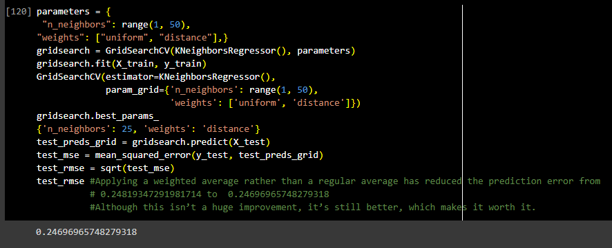

Fig: Improved accuracy using weighted average

1. Random Forest:

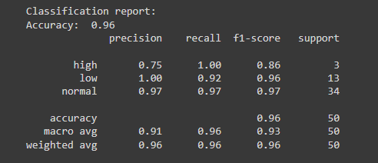

Fig: Accuracy: 96%

1. SVM:

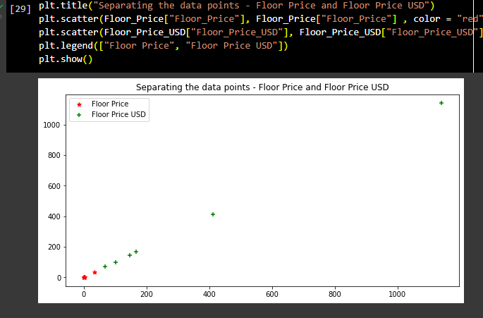

1. Confusion Matrix:

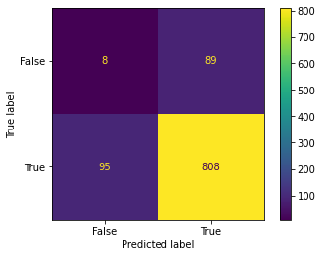

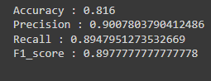

Fig: Accuracy: 81.6% of using Confusion Matrix.

# **Conclusion**

In this paper, [7] it is found that floor price is an important factor influencing and getting faster NFTs as well as the price of NFTs to become an owner of them easily in Marketplace [8]. The Machine Learning Web Application of “NFT Floor Price Prediction Authenticator" has evaluated the effectiveness of using the lowest floor price to find the best NFT assets. The results revealed that, compared to other models using Random Forest Model, Confusion Matrix, KNN (K-Nearest Neighbors) Algorithm give the best accuracies that can be applied on the application.

##### **References**

|  |  |
| --- | --- |
| [1] | Schaar, Luisa and Stylianos Kampakis, "Non-fungible tokens as an alternative investment: Evidence from cryptopunks," *The Journal of The British Blockchain Association,* p. 31949, 2022. |
| [2] | "NFT Price Floor," [Online]. Available: https://nftpricefloor.com/. |
| [3] | "Statista," [Online]. Available: https://www.statista.com/statistics/1265565/nft-floor-rate/. |
| [4] | Schnoering, Hugo and Hugo Inzirillo, *Constructing a NFT Price Index and Applications. arXiv preprint arXiv:2202.08966.,* 2022 Feb 10. |
| [5] | "D. Piyadigama and G. Poravi, “An analysis of the features considerable for NFT recommendations, arXiv: 2205.00456.," May 2022. |
| [6] | D. Wayne, "Using machine learning to valuate the Bored Ape NFTs, Blogchain.," [Online]. Available: Available: https://blogchain.ca/bayc-value-estimation. |
| [7] | M. Marroc, "Floor Price of NFT Projects," Jul 2022. [Online]. Available: https://medium.com/coinmonks/floor-price-of-nft-projects-355ce6cb10ac. |
| [8] | "Trending NFT Collections by Sales," [Online]. Available: https://icy.tools/collections. |